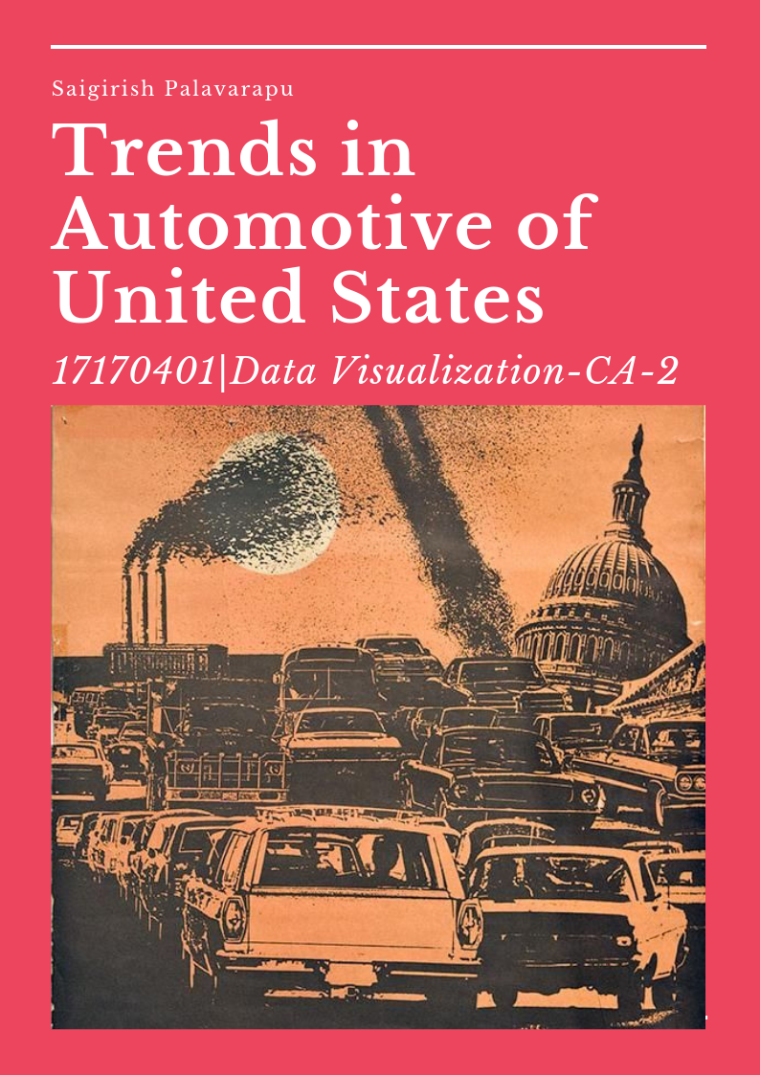

[Year]

Sai Girish Palavarapu

[Company name]

[Date]

Table of Contents

About the dataset: 2

Flow of Process to develop Infographics 2

Procurement and pre-processing of Data 2

Analysing and Visualisation 2

Designing and Infographics 2

Story behind the infographic 2

Justification 3

Techniques 3

Visualizations used in Infographics 3

Area under line graph (Tableau): 3

Line Graph (Tableau): 3

Stacked Column Chart (Tableau): 3

Bubble Cloud (Tableau): 3

Line graph (Tableau): 3

Layout 3

Style 3

Colours: 4

Technologies used in Infographics 4

IBM-SPSS: 4

Tableau: 4

Short Reflection 4

Advantages 4

DisAdvantages 4

Link to download the dataset: 4

Bibliography 4

# About the dataset:

The Environmental protection Agency (EPA) of U.S is maintaining and updating the data of emission of Carbon dioxide (Co2) and Miles per gallon (MPG) by the vehicles like different models of cars and trucks from past 44 years. The total data that is from 1975 to 2017, which is fixed on the bases of data submitted to EPA and National Highway Traffic Safety Administration (NHTSA) which is an organization of the Executive Branch of the U.S. government.

In this dataset it includes Fuel economy of the vehicle and Co2 emission in city as well as in highway which also includes the type of vehicle, year of the model that has been released, and also, to which class it belongs to. This data also includes the production share of the particular vehicle type with its weight (Lbs) and horsepower. This specific information of vehicles is useful to find out many useful metrics that can be used in the business environment and also to derive various relations between different non-trivial fields.

# Flow of Process to develop Infographics

Various methods of infographics and data visualization are in existence, but majorly and universally there are only 3 types of important methods are followed by the people they are 1) interactive 2) motion 3) Static. But in this paper, we used and developed only Static type of infographics in which the viewers cannot think out of the information that is provided in front of them. [1]

## Procurement and pre-processing of Data

The data is primarily available as an open source in the EPA website and the link to get the data is given the below section. Firstly, it is downloaded as a CSV (Comma separated value) file which is not useful to visualise it. We then import data to SPSS for analysing.

## Analysing and Visualisation

Analysis of data is done using SPSS and then found the relation between the variables. The SPSS file needs to be import to Tableau and data measures and dimensions are divided automatically by Tableau. Based on our requirements we need to place them in x and y axis of the tool to visualise it. Tableau provides different types of graphs and charts, based on the requirement we need to select the appropriate option for better visualization. Five visualizations have been created using the data, which are of different to one another. The created visualizations are then exported as images individually, so that they can be used for further purpose.

## Designing and Infographics

Infographics is prepared using an online tool called Visme which is free and publicly usable also there are many other tools which can be used to develop infographics in online, but the framework of creating the infographic is much similar in all the tools.

A template needs to be selected for an infographic before its development. A size of A4 sheet with 21cm*29.7cm where an infographic needs to be built. Select an appropriate background colour so that the visualizations will be more effective. By using different facility provided by Visme the created infographics is more effective in less space. In this infographic image, there is no third-party infographics are used to provide the information.

# Story behind the infographic

Information graphics are three times more effective in studying and understanding the information when compared with the reading the data[2] in which the data is formatted in a story manner so that the viewer is more likely to understand the data. When we come to our data of trends in the automotive, the major theme behind the infographics is that to know that which types of vehicles are creating more pollution and what’s their trends in mileage and as well as their horsepower. We can know from the first area graph that which type of vehicles are having the highest production share that is sedan/wagon car is continuously having the highest production share than others that is nearly 41% and we look at its Co2 emission, they are more evolving the gas in city where people live more which is more dangerous.

When we compare the dismissal of Co2 from the vehicle from past 4 decades, it has been gradually decreasing but still need be more.

When we come to its MPG (Miles per gallon) which varies from vehicle to vehicle and differs between the companies, and it is also having improvement in increasing its capacity from past 3 decades but not in a rapid manner and there is an interesting segment comes into notice that MPG is high in highways rather than in cities and it is nearly 10% of change which is parallel same from 1975.

When we consider the horsepower of sedans/wagons, they are increasing in a steady state manner so from this we can say that automobile companies are trying to give less Co2 with higher MPG and Horsepower, so that the buyer will experience the essence of driving.

Quality of vehicle is dependent on many factors like generally metal used in manufacturing the car, its MPG, maintenance and many more, but if the company has used the quality metal in manufacturing the car then its obvious that its weight will be high, and its MPG will be low. When we look at the statistics of the data regarding the vehicle weight there is a sudden decrease and then after few years there is a study weight is maintained in cars. This may be because to maintain the required quality of vehicle. There is nearly 46% change of weight from its staring to the end of data. Finally, there is a considerable chance in automotive regarding all the aspects of Manufacturing and which are helpful for environment as well as to the future generations.

# Justification

While building the infographics an appropriate graph or chart type should be used. Colours used in the visualisation of data will also play a major role in understanding the information very clearly and quickly to the viewer [3].

## Techniques

Data analysis is a primary requirement for a best visualization. For data analysis we can use many tools available, some of them are MS Excel, IBM-SPSS, SAS, and so on. Among them I have used SPSS for knowing weather there is any missing values in the data or to know any relation between the variables.

When the logistic regression is used to analyse the factors effecting MPG we got nearly 30% of effect due to Horsepower and nearly 26% of effect on Co2 emission, these calculations are done using SPSS tool. When the numeric part is concluded then we go to the visualization section, for that Tableau is one of the best tools. We then use the measures and dimensions in X and Y axis with appropriate visualization type along with colours, so that the infographics will be effective to viewers which is so important to be considered. For representing time stamp data and qualitative data, bar charts, pie charts are more useful where as for quantitative, value bars are used [4]. For the infographic part, Visme is one of the popular tools that can provide different types of visual effects which are free.

## Visualizations used in Infographics

Area under line graph (Tableau): it is mainly used to forecast the Big-data which consists of large time periods

Line Graph (Tableau): It is Used because we need to compare two different variables difference over a large period of time.

Stacked Column Chart (Tableau): this chart is used to compare relative and absolute difference between two variables over time the same has been done.

Bubble Cloud (Tableau): This is used for un ordered data and this visualization it is used to find trends in Horsepower of vehicle which varies very rapidly in real time.

Line graph (Tableau): mainly is used for non-cylindrical data so the weight is an attribute that belongs to the same category in this case, so it is an appropriate method of visualization.

## Layout

Th information provided in the infographics are in a drill-down manner. It starts from the production share vehicles to the factors effecting Its MPG.

## Style

Information with graphics includes visuals, charts, text. its moto is to deliver a high amount of information with in a less space and time and this should be interactive to the viewers [5]

There are different styles of text and graphics are used in the infographics to develop an interest to the audients.

## Colours:

Colours in representing the data will play an important role in understanding it faster and better in our visualization we have used

Red: which indicates the criticality of the situation

Green: which indicates the normal nature of the data

Yellow: data in highway (Co2 and Highway)

Blue: data in city (Co2 and Highway)

# Technologies used in Infographics

There are different technologies and tools used while developing the infographics.

IBM-SPSS: Tool is used for analysing the data by applying the statistical methods and then save as an .sav file for further use.

Tableau: It is a high-performance visualization tool which provides different types of visualization techniques with a high accuracy

Visme: Infographic tool which has a capability to build different types of infographics with high resolution.

# Short Reflection

The building of Infographics has advantages as well as disadvantages as a beginner, some of them are

Advantages:1) It provided a chance for me to learn about the new tools and technologies that are used for visualization

2)This knowledge can also be utilised to create many more distinct infographics in future.

DisAdvantages:1) to represent the huge information in a single sheet is a challenging task.

2)The data consists of many useful constraints, but all cannot be used due to story-telling format.

Link to download the dataset: <https://www.epa.gov/automotive-trends/explore-automotive-trends-data>

# Bibliography

[1] BanuInanc Uyan Dur, “Data Visualization and Infographics in Visual Communication Design Education at

the Age of Information”, Journal of Arts and Humanities, Vol 3, Iss 5, Pp 39-50 (2014), MIR Centre Press,

2014, ISSN**:**2167-9045 2167-9053.

[2] I. R. Murray, A. D. Murray, S. J. Wordie, C. W. Oliver, A. W. Murray, and A. H. R. W. Simpson, “Maximising the impact of your work using infographics,” *Bone Jt. Res.*, vol. 6, no. 11, pp. 619–620, Dec. 2017.

[3] S. Silva, B. Sousa Santos, and J. Madeira, “Using color in visualization: A survey,” *Comput. Graph.*, vol. 35, no. 2, pp. 320–333, Apr. 2011.

[4] Linda L. Cooper, Felice S. Shore, “The Effects of Data and Graph Type on Concepts and Visualizations of

Variability”, Journal of Statistics Education Volume 18, Number 2 (2010), ISSN**:** 1069-1898.

[5] Christopher Toth, “Revisiting a Genre: Teaching Infographics in Business and Professional Communication

Courses”, Business Communication Quarterly 76(4) 446–457, 2013 by the Association for Business

Communication Reprints and permissions: sagepub.com/journals Permissions nav, ISSN**:**1080-5699, DOI:

10.1177/1080569913506253.